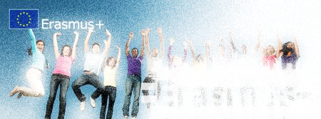
Erasmus + program ingoing to the University of Ferrara

- DON’T YOU KNOW FERRARA? LET’S SEE WHAT IS IT…
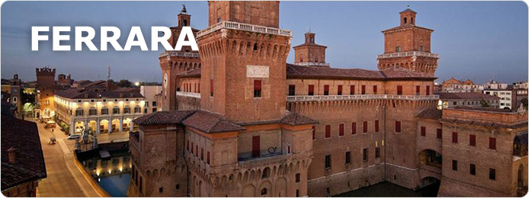
City of the Renaissance Founded in the 6th century, an important trading and political centre in the Middle Ages, it reached the highest peaks of Renaissance architecture and prestige with the Este family, one of the most enlightened courts of Europe, which hosted the most important scholars, writers and artists of the era.
In 1995, UNESCO granted the city World Heritage status as a wonderful example of a city planned in the Renaissance still keeping its historical centre intact.
...AND WHY YOU HAVE TO COME HERE TO STUDY, BUT NOT ONLY!
  - Let’s eat the best food ever Where you can eat
  - Enjoying Ferrara: night life and relax
  - You can also play a lot of sports...
  - Where you can sleep
- Where is Ferrara? Discovering Emilia Romagna…
  - How can you get there?
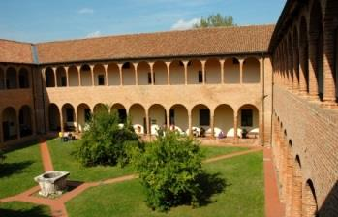
- Where you will study: UNIVERSITY OF FERRARA… Let’s take a look!
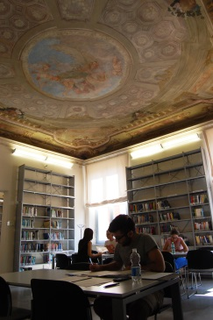
          - The University of Ferrara offers a unique historical environment.
Fostering innovative views of the future supported by deeply
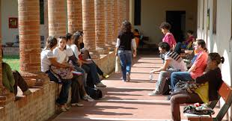
rooted cultural traditions is a primary goal of the University of Ferrara, which offers a broad range of BA and MA degrees and PhDs in the sciences and the humanities. The whole town is a lively campus thriving on the interaction between national and international students.

          - WHAT YOU CAN STUDY
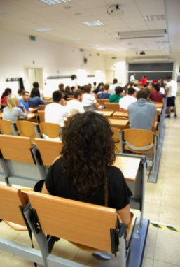
- DEPARTMENT of ECONOMICS & MANAGEMENT

The Department of Economics and Management (DEM) was created in 2013 from the previous Department of Economics Institutions and Territory, formed in 1997.
The scientific approach of the Department has always been characterized by a multidisciplinary. Today it represents the fields of economics, business and law.

  - UNDERGRADUATE COURSES:
      - Degrees in Economics
      - Master Degrees in Economics, Market & Management

  - WHICH SUBJECTS ARE TEACHING IN ENGLISH

  - N° OF ERASMUS LOCATIONS

  - SOME NUMBERS of Department of Economics and Management:

    - About 40 staff including teachers and researchers first and second band;
    - About 10 technicians;
    - About 30 research fellows, graduate students and collaborators;
    - About 2000 total members (academic year 2013/2014).

